This guide is maintained by CAMRA’s Conference Procedures Committee (CPC) and advises members, branches, and regions on how to propose motions for debate at Conference.

More information on CPC, including meeting minutes, contact details, and updates on the current Conference cycle is here: camra.org.ukcpc

Other volunteering opportunities in the Campaign are on the website from: camra.org.uk/volunteer

Contents

1. General guidance on submitting motions | 1
2. Wording and content of motions | 2
2.1 Wording | 2
2.2 Content | 2
3. Why CPC may change the wording of motions | 3
4. Other important information about CPC’s decision-making processes | 3
5. Drafting advice from CPC | 4
6. Process flowchart | 5
7. Motions on internal matters | 5
8. Amendments and emergency motions | 6
8.1 Amendments | 6
8.2 Emergency motions | 6
8.3 How to submit amendments and emergency motions | 6
9. Standing Orders | 6
10. Reasonable adjustments | 7
11. CPC Remit and Procedures | 7
12. Contact | 7

- General guidance on submitting motions

- It is strongly advised that you read the entirety of this guidance before submitting a motion for consideration.

- Deadlines relating to submitting motions and requesting drafting advice for that Conference year will appear on the CAMRA website at: camra.org.uk//cpc.
- Motions should be submitted using the form at the link above (the form will only be visible when the motions process is open – usually from November to February the next year).

- You can also download a paper copy of the form and post it to CPC Secretary, 230 Hatfield Road, St Albans, AL1 4LW.

- All motions submitted will be acknowledged by the CPC Secretary. If you have not received acknowledgement of your motion by 3pm on the submission deadline date or within five working days of submission (whichever is earlier), please email cpcsecretary@camra.org.uk to confirm receipt.

- Wording and content of motions

The flowchart in Section 6 illustrates the process that should be followed before submitting a motion for debate.

  - Wording

- Motions should usually start with the words "This Conference..."

- The motion should create policy guidelines by instructing someone or something, condemning, advising or amending.

- The motion should not include detailed reasoning or arguments. That should be reserved for the debate on the motion at Conference.

- If you are not sure how to write your motion, you can ask for drafting advice from CPC (covered in Section 5 below).

  - Content

- Motions repeating existing policy will not be accepted unless they are clearly intended to remind Conference of policies which are being ignored.

- Motions that involve administration, internal issues or procedures will not be accepted unless the procedure for making a suggestion or complaint has been followed under 6.1.4.2 of CPC’s Remit. There is more information on this in Section 7.

- Motions raising issues debated in recent years' Conferences will not usually be accepted or they will be given very low priority unless there are exceptional or changed circumstances.

- Motions should be on one subject only. CPC will split motions that deal with more than one subject.

CAMRA’s Policy Documents are here. They are divided between internal and external documents to assist you in identifying the nature of your motion.

CAMRA maintains an archive of motion results, which you may wish to consult when considering the content and drafting the wording of your motion: camra.org.uk/campaign-resources/camra-conference-motions-archive-26881

- Why CPC may change the wording of motions

Many motions submitted for consideration are changed by Conference Procedures Committee before they appear on the Conference Order Paper.

This is often to ensure the motion makes sense or to make the intent of the motion clear. Because of the short time available between the closing date for submission of motions and the completion of the Order Paper, it may not be possible to consult the proposers of the motion before such changes are made.

The best way to avoid this situation arising is to submit your motion to CPC for drafting advice at least 14 days before the deadline for receipt of motions (see Section 5 below for more details).

- Other important information about CPC’s decision-making processes

- CPC will not accept motions on topics that are outside of CAMRA’s Objects, as defined in the CAMRA Articles of Association.

- CPC will composite similar motions on the same subject submitted by different branches or individuals.

- CPC will, if possible, consult the proposers about any significant changes to the wording of motions but, if contact cannot be made at short notice, it will proceed as it sees fit. It is essential therefore that two contact names and phone numbers are included with the proposed motion.

- The proposer and seconder are expected to attend Conference to propose their motion which may be tabled for any stage of Conference business.

- CPC may not accept a motion if it is clear that the proposer and seconder will not intend to attend Conference. If, once a motion is included on the Order Paper, the proposer and seconder do not attend the Conference, CPC may recommend that the motion be withdrawn if the proposer and/or seconder have not confirmed substitutes to allow the motion to be debated.

- The CPC Secretary will write to proposers of motions to confirm the outcome of the CPC meeting to set the Order Paper. This usually happens in the week following the meeting.

- Proposers have the right to appeal CPC’s decision.This takes the form of a representation to the meeting of CPC on the eve of Conference (which takes place in or near the Conference venue).

- Dates of meetings are published on the CAMRA website at: camra.org.uk//cpc. Any CAMRA member can attend a CPC meeting. Please contact the CPC Secretary on cpcsecretary@camra.org.uk to request to attend and receive meeting papers.

- Drafting advice from CPC

Conference Procedures Committee can offer drafting advice on motions to members and branches. Requests must have been received two weeks prior to the deadline for receipt of motions.

This is strongly advised for those submitting a motion for the first time. Seeking drafting advice can reduce the likelihood that a motion is rejected for procedural reasons, or the wording is heavily amended without consultation with proposers.

Process for requesting drafting advice:

- The deadline to request drafting advice is always 14 days before the deadline for submitting motions for consideration.

- Requests for drafting advice should be submitted using the form here:camra.org.uk//cpc, Please check the box that indicates that you want to receive drafting advice.

- You can also download a paper copy of the form and post to CPC Secretary, 230 Hatfield Road, St Albans, AL1 4LW.

- Process flowchart

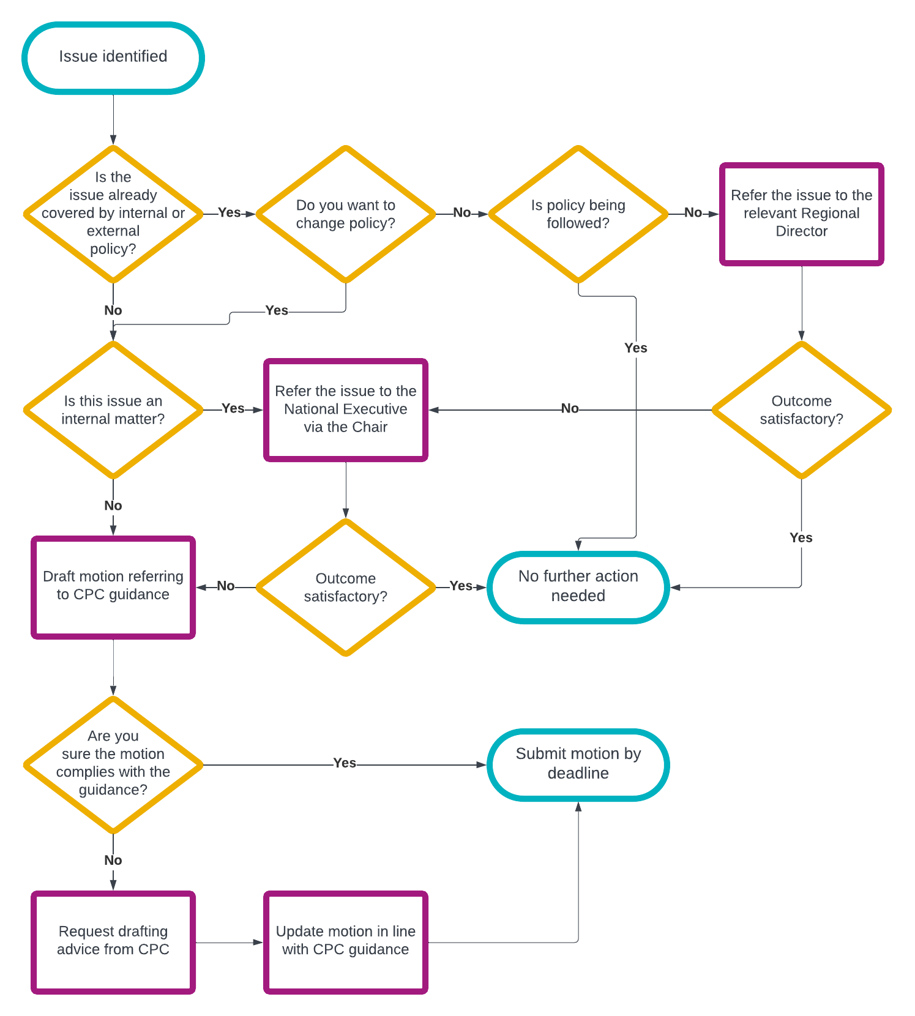

- Motions on internal matters

- If your motion relates to internal matters (e.g. the administration of the campaign, support provided for branches, policies relating to our events and commercial activities), you must exhaust CAMRA’s internal decision-making processes before CPC will consider the motion for inclusion on the Order Paper.

- This means raising the subject/issue with the CAMRA Chairman first – they will then likely ask the relevant national committee to consider your request. This may result in changes to policy or practices and therefore not require a motion.

- If you are not satisfied with the outcome, you can then raise the proposed policy change via a Conference motion.

- CPC may still make changes to your motion when you have followed the correct process for raising internal matters via Conference.

- Amendments and emergency motions

  - Amendments

Members can submit amendments to motions once the Order Paper for Conference has been published. These are considered by CPC at their meeting on the eve of Conference.

Amendments will only be accepted during debate at Conference in exceptional circumstances.

  - Emergency Motions

Emergency motions can be submitted once the deadline for receipt of motions has passed. As with amendments, these are also considered by CPC at their meeting on the eve of Conference.

Emergency motions are defined as those where the situation requiring the motion arose after the deadline for submission of ordinary motions and could not have been anticipated before the deadline.

  - How to submit amendments and emergency motions

Where possible, please submit both amendments and emergency motions in advance of the meeting to the CPC Secretary on cpcsecretary@camra.org.uk.

When submitting emergency motions, it is helpful to outline why the motion meets the criteria for a true emergency.

The CPC Secretary will write to proposers immediately following the CPC meeting to inform them of the outcome. Most people submitting amendments and emergency Motions choose to attend the CPC meeting on the eve of Conference.

- Standing Orders

Conference Standing Orders are the rules by which debate at Conference is conducted. They set out who speaks, in what order, and for how long. They all cover the types of procedural motions that can be proposed during debate, and how they will be handled.

The CAMRA Chairman is the Chair of Conference. CPC advise the Chairman on the application of the Conference Standing Orders during Conference debates.

Standing Orders are published here: camra.org.uk//cpc, once CPC have agreed the Standing Orders for the coming year.

If you have queries about the Standing Orders or want to make a representation about changes to the Standing Orders, please contact the Chair of CPC via the CPC Secretary on cpcsecretary@camra.org.uk.

- Reasonable Adjustments

CAMRA is committed to ensuring that our members can contribute to the Campaign. We will make reasonable adjustments to ensure that you can take part in CAMRA’s policy making processes. This includes on-site access issues at Conference.

To let us know about any adjustments, or discuss your requirements, please contact the CPC Secretary on cpcsecretary@camra.org.uk.

- CPC Remit and Procedures

Any member considering submitting a motion to Conference is advised to read the full Conference Procedures Committee Remit at: camra.org.uk//cpc

Members may wish to pay specific attention to Section 6.1 which details the process followed by Conference Procedures Committee at the meeting held to discuss submitted motions and set the Order Paper.

- Contact

For initial queries, or to be put in touch with the Chair of Conference Procedures Committee, please email cpcsecretary@camra.org.uk

